**Assignment 1**

**Q1**

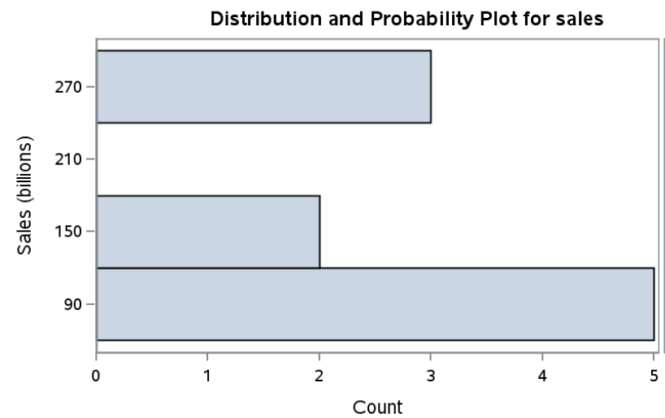

**Comments:** the histogram for Sales shows that the distribution of Sales is skewed with most cases on the lower end, and there seems to be a break.

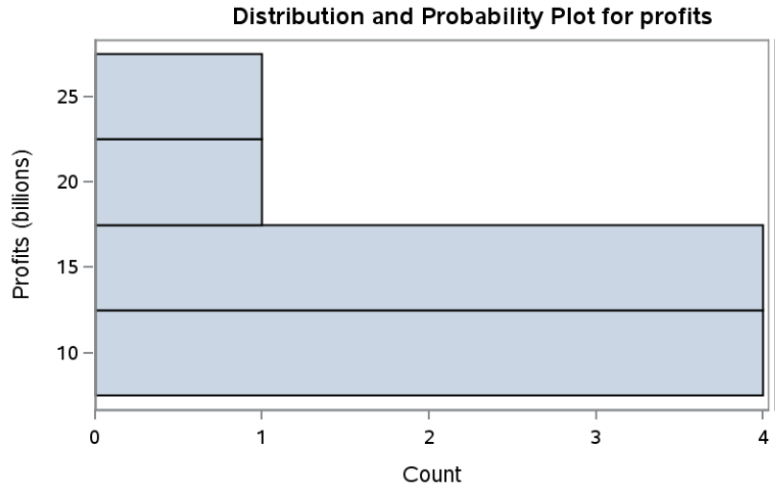

**Comments:** the histogram for Profits shows that the distribution of Profits is quite skewed and spread out, with most cases on the lower end.

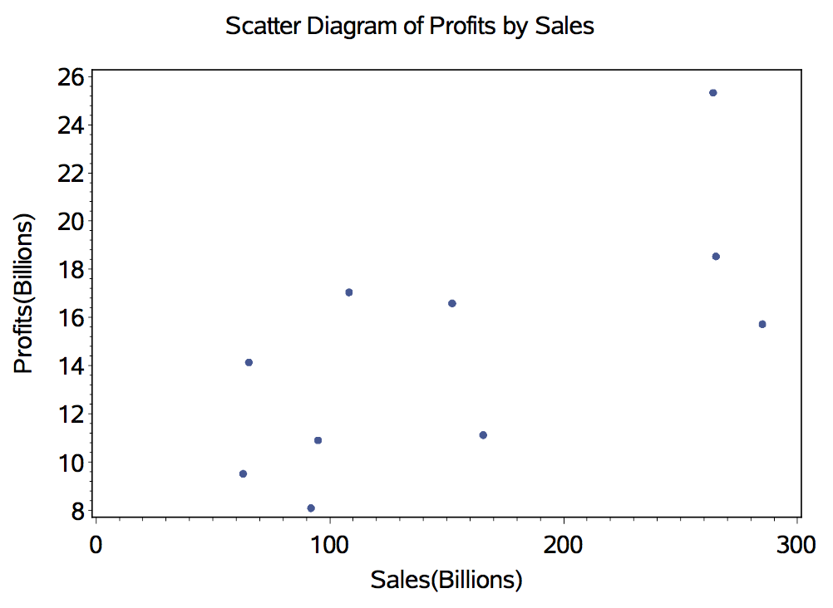

**Comments:** it seems that there’s a positive relationship between Sales and Profits. The higher the Sales, the higher the Profits.

1. *x1\bar* = 155.60; *x2\bar* = 14.70; *s11*= 7476.45; *s22* = 26.19; *r12* = 0.69;   
   The correlation of 0.69 is large, according to Cohen’s (1988) interpretation of effect sizes. This means that the Sale is positively associated with Profits, which is consistent with what we found with the scatter plot in (a).

**Q2**

1. length of x = 6.78; length of y = 2.45; length of z = 1.73.
2. The angles between x and y = 93.45°, x and z = 31.65°, y and z = 61.87°.
3. The project of x onto z is $\left(\begin{matrix}3.3333 \\ 3.3333 \\ 3.3333\end{matrix}\right)$, y onto z = $\left(\begin{matrix}0.6667 \\ 0.6667 \\ 0.6667\end{matrix}\right)$.
4. The projection of x onto y is $\left(\begin{matrix}0.1667 \\ -0.3333 \\ -0.1667\end{matrix}\right)$, y onto x is $\left(\begin{matrix}-0.1304 \\ -0.0217 \\ -0.0652\end{matrix}\right)$. The projection of x onto y is the not same as that of y onto x, because the direction of y is not the same as that of x.

**Q3**

1. **1’A** = (5,3,7)
2. **1A** is impossible to compute, because the number of columns in **1** is not the same as the number of rows of **A**.
3. **A1** = $\left(\begin{matrix}11 \\ -1 \\ 5\end{matrix}\right)$
4. **A1’** is impossible to compute, because the number of columns in **A** is not the same as the number of rows in **1’**.
5. **2A** = $\left(\begin{matrix}12 & 2 & 8 \\ -4 & 0 & 2 \\ 2 & 4 & 4\end{matrix}\right)$
6. **A + B** = $\left(\begin{matrix}8 & 1 & 6 \\ -5 & 1 & 2 \\ 3 & -2 & 3\end{matrix}\right)$
7. **2A – 3B** = $\left(\begin{matrix}6 & 2 & 2 \\ 5 & -3 & -1 \\ -4 & 16 & 1\end{matrix}\right)$
8. **(2A)’ – (3B)’** = $\left(\begin{matrix}6 & 5 & -4 \\ 2 & -3 & 16 \\ 2 & -1 & -1\end{matrix}\right)$
9. **AB** = $\left(\begin{matrix}17 & -15 & 17 \\ -2 & -4 & -3 \\ 0 & -6 & 6\end{matrix}\right)$
10. **BA** = $\left(\begin{matrix}14 & 6 & 12 \\ -19 & -1 & -9 \\ 21 & 4 & 6\end{matrix}\right)$, and it’s not the same as the result obtained in (i), although the   
      
    dimension (i.e., 3X3) is the same.
11. **A’B’** = $\left(\begin{matrix}14 & -19 & 21 \\ 6 & -1 & 4 \\ 12 & -9 & 6\end{matrix}\right)$
12. **(BA)’** = $\left(\begin{matrix}14 & -19 & 21 \\ 6 & -1 & 4 \\ 12 & -9 & 6\end{matrix}\right)$, which is the same as the results obtained in (k).
13. **CB** = $\left(\begin{matrix}8 & 0 & 8 \\ -9 & 3 & 3 \\ 2 & -4 & 1\end{matrix}\right)$
14. **BC** = $\left(\begin{matrix}8 & 0 & 2 \\ -12 & 3 & 1 \\ 8 & -12 & 1\end{matrix}\right)$, which is not equal to the result obtained in (m), although the  
      
     diagonals are the same for (m) and (n), because C is a diagonal matrix.

**Q4**

1. **(A + B) + C = $\left(\begin{matrix}0 & 5 \\ 1 & 7\end{matrix}\right)+\left(\begin{matrix}3 & 1 \\ 2 & 1\end{matrix}\right)$** = $\left(\begin{matrix}3 & 6 \\ 3 & 8\end{matrix}\right)$  
     
   **A + (B + C)** = $\left(\begin{matrix}2 & 4 \\ 1 & 3\end{matrix}\right)+ \left(\begin{matrix}1 & 2 \\ 2 & 5\end{matrix}\right)= \left(\begin{matrix}3 & 6 \\ 3 & 8\end{matrix}\right)$ Therefore, (**A** + **B**) + **C** = **A** + (**B** + **C**)
2. **(AB)C** = $\left(\begin{matrix}-4 & 18 \\ 2 & 13\end{matrix}\right) \left(\begin{matrix}3 & 1 \\ 2 & 1\end{matrix}\right)= \left(\begin{matrix}24 & 14 \\ 20 & 11\end{matrix}\right)$  
     
   **A(BC)** = $\left(\begin{matrix}2 & 4 \\ 1 & 3\end{matrix}\right) \left(\begin{matrix}-4 & -1 \\ 8 & 4\end{matrix}\right)= \left(\begin{matrix}24 & 14 \\ 20 & 11\end{matrix}\right)$  
     
   Therefore, (**AB**)**C** = **A**(**BC**).
3. **A(B + C)** = $\left(\begin{matrix}2 & 4 \\ 1 & 3\end{matrix}\right) \left(\begin{matrix}1 & 2 \\ 2 & 5\end{matrix}\right)= \left(\begin{matrix}10 & 24 \\ 7 & 17\end{matrix}\right)$  
     
   **AB** + **BC** = $\left(\begin{matrix}-4 & 18 \\ -2 & 13\end{matrix}\right)+ \left(\begin{matrix}14 & 6 \\ 9 & 4\end{matrix}\right)= \left(\begin{matrix}10 & 24 \\ 7 & 17\end{matrix}\right)$  
     
   Therefore, **A**(**B** + **C**) = **AB** + **BC.**